**EECS 360**

**Lab 10**

**11/8/16**

**Chen Long**

1. **Objective**

This lab is about how to pick the right sample rate, and we will learn it by choosing difference sample rate.

1. **Description**

We will pick three sampling period, which are 0.001s, 0.05s, 0.1s. We will use cosine equation for part 1, and we will use some new command to implement rect, sinc, and spline.

1. **Result**

As what we expect, there would be an unambiguous result, and one with oversampling, and another one with undersampling. First of all, we have to know in what sampling period would be the best. The way to found it is to find the actual period for a function. For example, cos(20*pi*t), we can consider it as cos(2*pi*t/(1/10)), so in this case, the period is 1/10, which is 0.1S. The best sampling period should be T/2, which is 0.05S. Therefore, we can see that in Figure1, when the sampling period is 0.05S, it has the best result, and when Ts=0.1S, we loss some data, and when T=0.001s, it’s too much data we don’t need. The same theory applies to every other graph, in some case, we even get an empty result because the sampling rate is too low; therefore, lower the sampling rate is always better than make it big because we will at least not losing information.

1. **Result**

This lab is a knowledge of enhancement of the previous lab, we have already known a little of this concept by lab 4, but this is the lab that we actually proving it systematically. We also know a new command line, Spline, this is the command line to implement sinc, but it is faster than “sinc” command line.

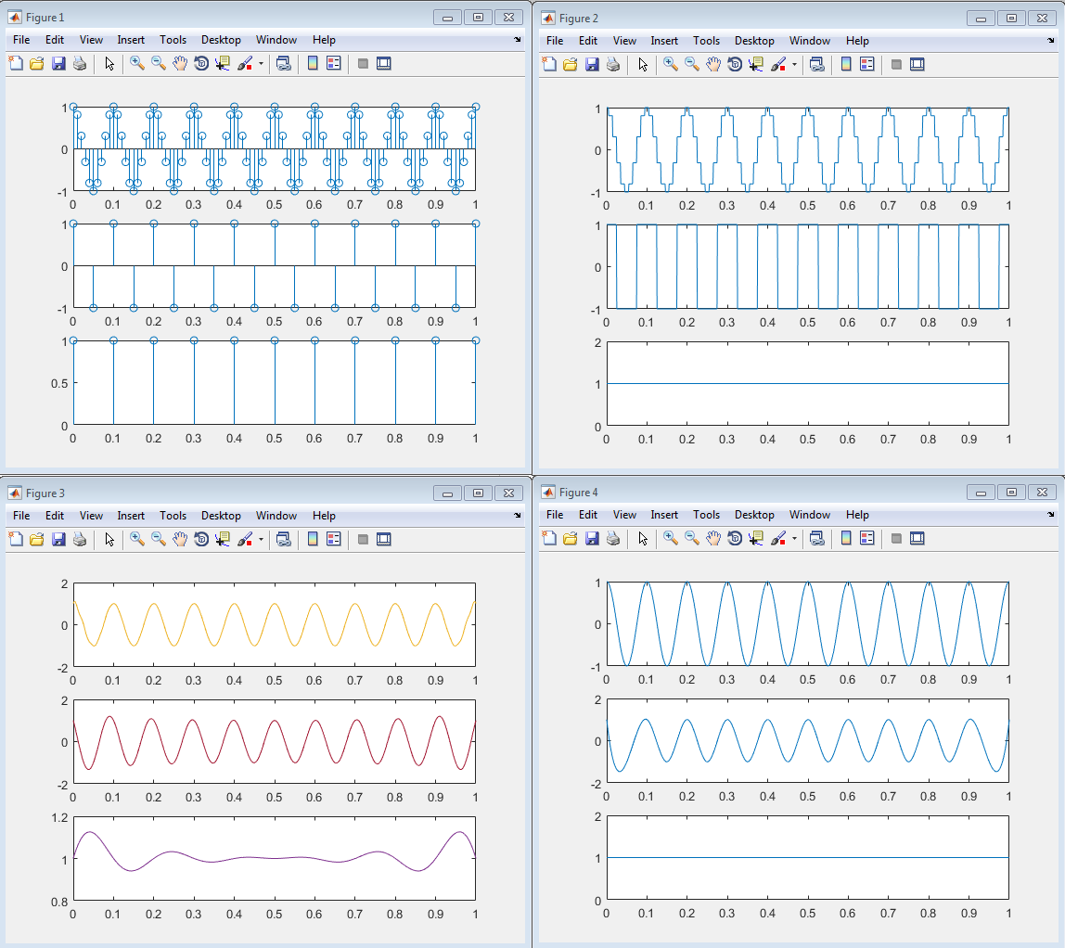

**MATLAB CODE**

clear all;

% part 2

Ts=0.01;

n=0:Ts:1;

x1=cos(20*pi*n);

subplot(311);

stem(n,x1);

% Ts=0.05

Ts=0.05;

n=0:Ts:1;

x1=cos(20*pi*n);

subplot(312);

stem(n,x1);

% Ts=0.1

Ts=0.1;

n=0:Ts:1;

x1=cos(20*pi*n);

subplot(313);

stem(n,x1);

% part 3

% rectpuls

figure(2);

ta=0:0.001:1;

Ts1=0.01;

n1=0:Ts1:1;

Fs=1/Ts1;

N=length(n1);

x=cos(20*pi*n1);

yrect1=zeros(N,length(ta));

for i=1:N

yrect1(i,:)=x(i)*rectpuls(Fs*ta-i+1);

end

subplot(311);

plot(ta, sum(yrect1));

% T=0.05

Ts1=0.05;

n1=0:Ts1:1;

Fs=1/Ts1;

N=length(n1);

x=cos(20*pi*n1);

yrect1=zeros(N,length(ta));

for i=1:N

yrect1(i,:)=x(i)*rectpuls(Fs*ta-i+1);

end

subplot(312);

plot(ta, sum(yrect1));

% T=0.1

ta=0:0.001:1;

Ts1=0.1;

n1=0:Ts1:1;

Fs=1/Ts1;

N=length(n1);

x=cos(20*pi*n1);

yrect1=zeros(N,length(ta));

for i=1:N

yrect1(i,:)=x(i)*rectpuls(Fs*ta-i+1);

end

subplot(313);

plot(ta, sum(yrect1));

% sinc

ta=0:0.001:1;

figure(3);

% T=0.001

Ts1=0.01;

n2=0:Ts1:1;

t=n2;

Fs=1/Ts1;

N=length(n2);

xa=cos(20*pi*t);

for i=1:N;

ysinc7(i,:)=xa*sinc(Fs*(ones(length(t),1)*ta-t'*ones(1,length(ta))));

end

subplot(311);

plot(ta, ysinc7);

% T=0.05

Ts2=0.05;

n2=0:Ts2:1;

t=n2;

Fs=1/Ts2;

N=length(n2);

xa=cos(20*pi*t);

for i=1:N;

ysinc72(i,:)=xa*sinc(Fs*(ones(length(t),1)*ta-t'*ones(1,length(ta))));

end

subplot(312);

plot(ta, ysinc72);

% T=0.1

Ts3=0.1;

n2=0:Ts3:1;

t=n2;

Fs=1/Ts3;

N=length(n2);

xa=cos(20*pi*t);

for i=1:N;

ysinc73(i,:)=xa*sinc(Fs*(ones(length(t),1)*ta-t'*ones(1,length(ta))));

end

subplot(313);

plot(ta, ysinc73);

% spline

figure(4);

% T=0.01

ts=0.01;

n4=0:ts:1;

ys10=spline(n4,cos(20*pi*n4),ta);

subplot(311);

plot(ta, ys10);

% T=0.05

ts2=0.05;

n4=0:ts2:1;

ys10=spline(n4,cos(20*pi*n4),ta);

subplot(312);

plot(ta, ys10);

% T=0.1

ts3=0.1;

n4=0:ts3:1;

ys10=spline(n4,cos(20*pi*n4),ta);

subplot(313);

plot(ta, ys10);